Docker pull justin321/hw_3

Docker images

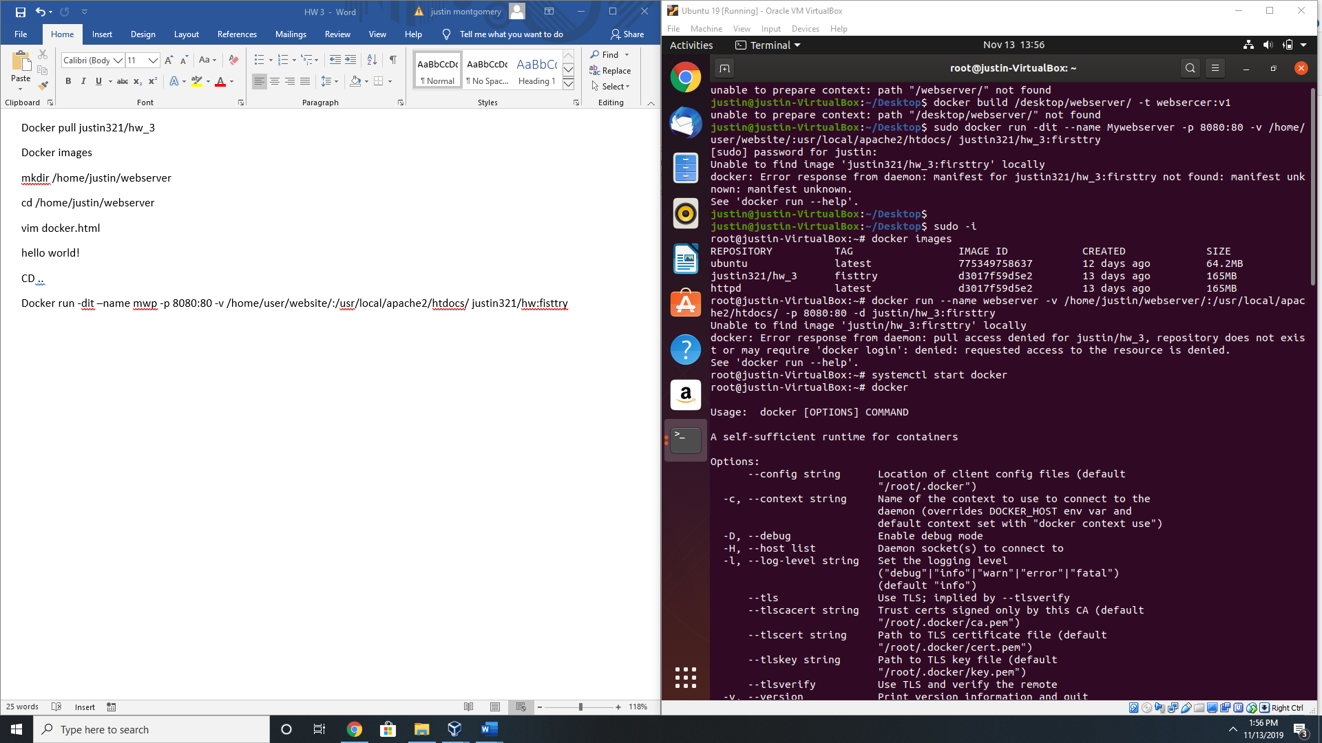

mkdir /home/justin/webserver

cd /home/justin/webserver

vim docker.html

<!DOCTYPE html>

<html>

<body>

<h1> Hello World!</h1>

<p></P>

</body>

</html>

CD ..

Docker run -dit –name mwp -p 8080:80 -v /home/user/website/:/usr/local/apache2/htdocs/ justin321/hw:fisttry

Docker push justin321/hw_3

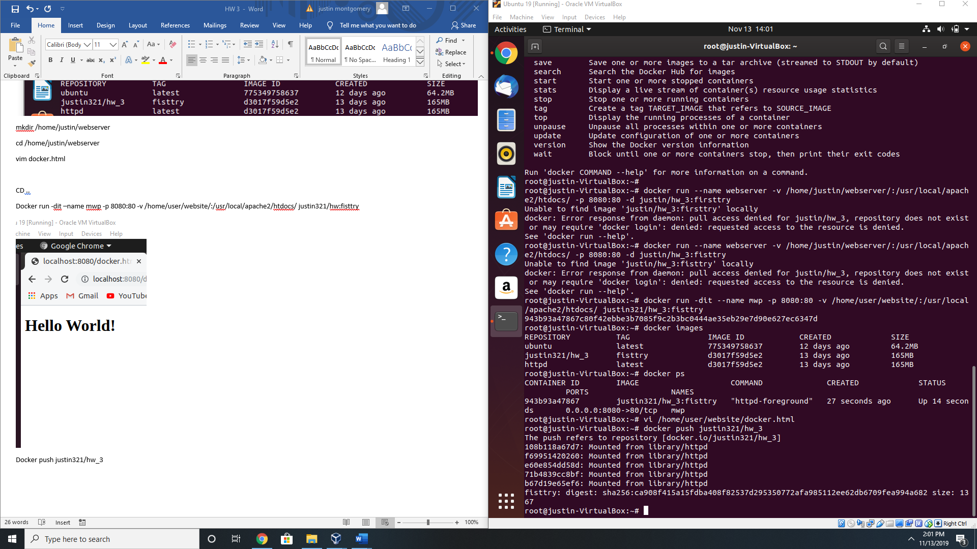

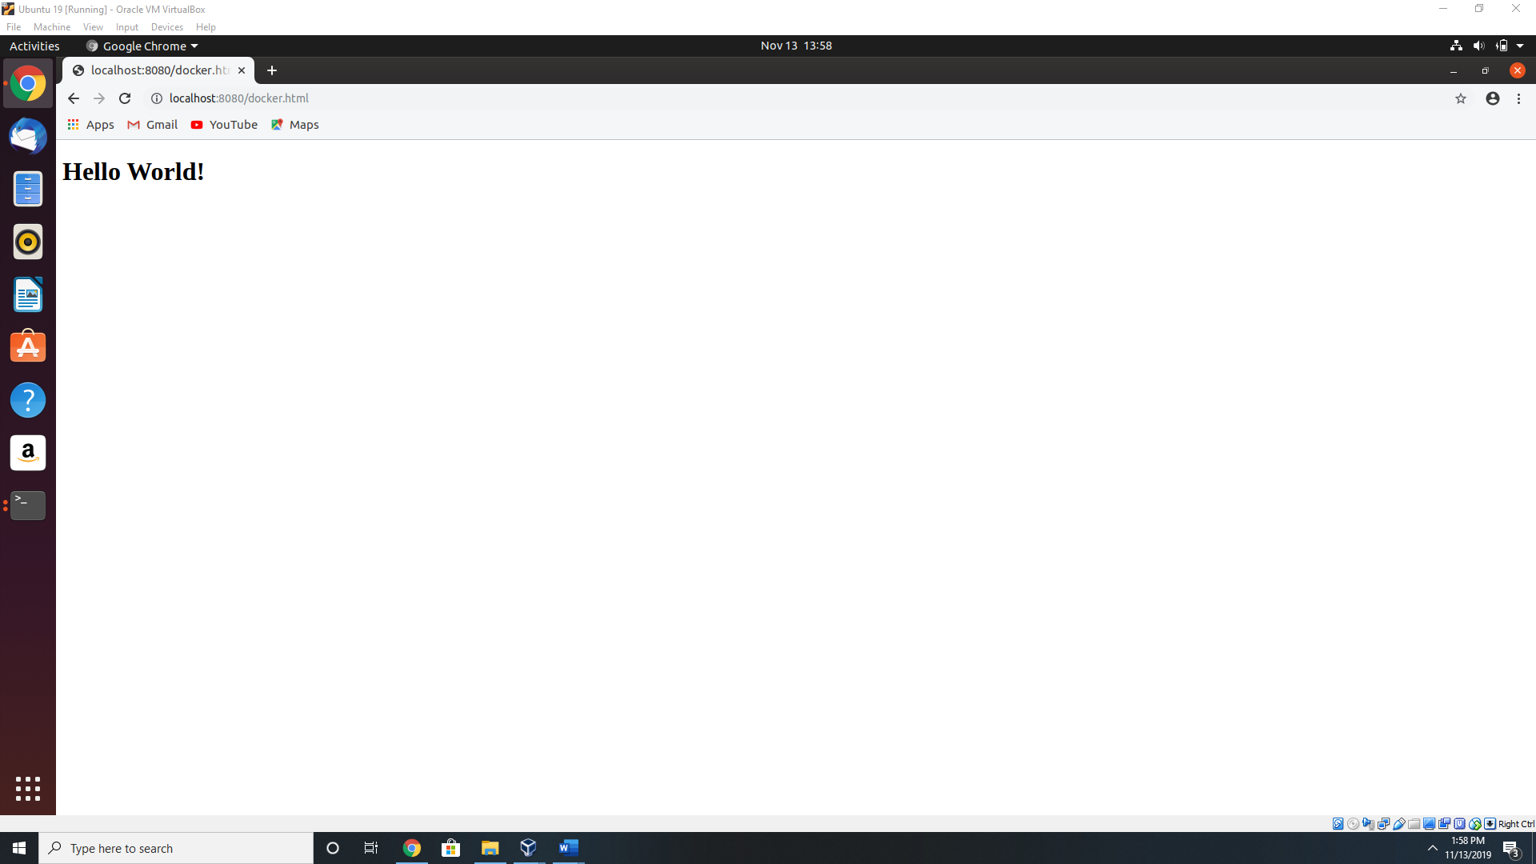

https://hub.docker.com/repository/docker/justin321/hw_3